ANDROID STUDIO

About Android Studio:

Based on JetBrains' IntelliJ IDEA software, Android Studio is designed specifically for Android development. It is available for download on Windows, Mac OS X and Linux, and replaced Eclipse Android Development Tools (ADT) as Google's primary IDE for native Android application development.

Requirements for Android Studio:

Windows:
- Microsoft® Windows® 8/7/Vista/2003 (32 or 64-bit)
- 2 GB RAM minimum, 4 GB RAM recommended
- 400 MB hard disk space + at least 1 G for Android SDK, emulator system images, and caches
- 1280 x 800 minimum screen resolution
- Java Development Kit (JDK) 7
- Optional for accelerated emulator: Intel® processor with support for Intel® VT-x, Intel® EM64T (Intel® 64), and Execute Disable (XD) Bit functionality
Installation of Android Studio:
- Android studio IDE
- Android SDK tools
- Android 6.0(Marshmallow)Platform
- Android 6.0 emulator system image with Google APIs
http://developer.android.com/sdk/index.html#top

To Create Project in Android Studio:
1.In Android Studio, create a new project:
- If you don't have a project opened, in the Welcome screen, click New Project.
- If you have a project opened, from the File menu, select New Project.
2.Under Configure your new project, fill in the fields as shown in figure 1 and click Next.
It will probably be easier to follow these lessons if you use the same values as shown.
- Application Name is the app name that appears to users. For this project, use "My First App."
- Company domain provides a qualifier that will be appended to the package name; Android Studio will remember this qualifier for each new project you create.
- Package name is the fully qualified name for the project (following the same rules as those for naming packages in the Java programming language). Your package name must be unique across all packages installed on the Android system. You can Edit this value independently from the application name or the company domain.
- Project location is the directory on your system that holds the project files

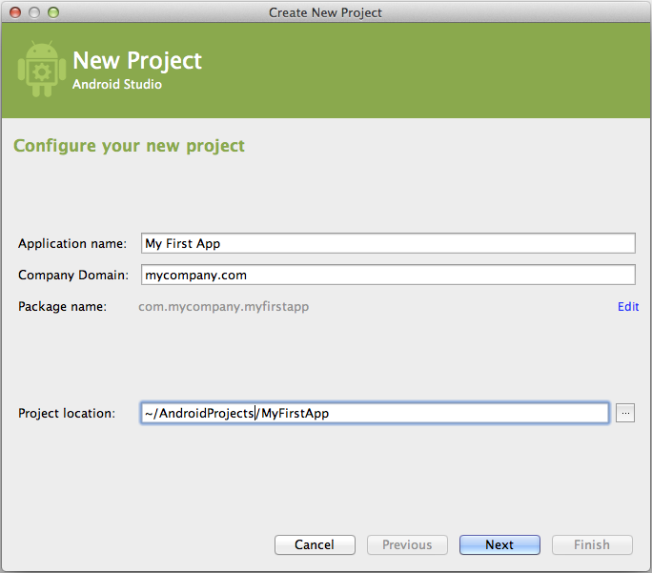
Figure 1
3.Under Select the form factors your app will run on, check the box for Phone and Tablet
4.For Minimum SDK, select API 8: Android 2.2 (Froyo).

5.Leave all of the other options (TV, Wear, and Glass) unchecked and click Next.
6.Under Add an activity to <template>, select Blank Activity and click Next.
7.Under Choose options for your new file, change the Activity Name to MyActivity. The Layout Name changes to activity_my, and the Title to MyActivity. The Menu Resource Name ismenu_my.
8.Click the Finish button to create the project.
Your Android project is now a basic "Hello World" app that contains some default files is created.
Run the app On Emulator:
Whether you're using Android Studio or the command line, to run your app on the emulator you need to first create an Android Virtual Device (AVD). An AVD is a device configuration for the Android emulator that allows you to model a specific device.
Creating an AVD
Launch the Android Virtual Device Manager:
- In Android Studio, select Tools > Android > AVD Manager, or click the AVD Manager icon  in the toolbar.
- Or, from the command line, change directories to sdk/ and execute:
tools/android avd
Note: The AVD Manager that appears when launched from the command line is different from the version in Android Studio, so the following instructions may not all apply.
Run the app from Android Studio
- In Android Studio, select your project and click Run from the toolbar.
- In the Choose Device window, click the Launch emulator radio button.
- From the Android virtual device pull-down menu, select the emulator you created, and click OK.
It can take a few minutes for the emulator to load itself. You may have to unlock the screen. When you do, My First App appears on the emulator screen.
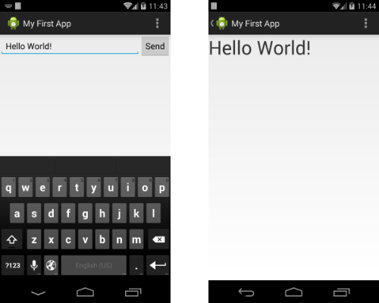

Android Studio Project Structure:
1. Main Project
- This would be entire project context.Whatever you do in IntelliJ IDEA, you do that in the context of a project.A project is an organizational unit that represents a complete software solution.A project in Android Studio is like a workspace in Eclipse. In android Studio a project,can contain multiple modules. A module in Android Studio is like a project in Eclipse.In the above screenshot “LoginAuthenticator” is the name of my project.
- This means that, in theory it is possible to build multiple apps with in the same project. From my personal experience, creating multiple apps with in the same project doesn’t works well. So, I recommend not to make your hands dirty trying the same thing. Instead, It is a better idea to create single app per single project.
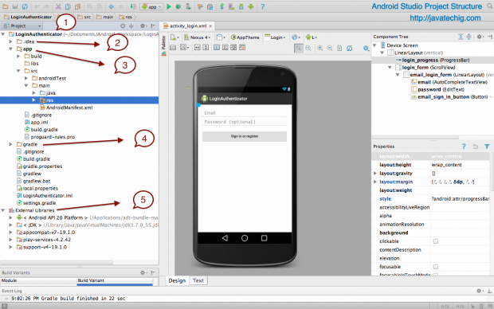
2. .idea
Eclipse uses project.properties file for project specific metadata. Here in android studio, this .idea does the same thing. This means the project specific metadata is stored by Android Studio.
3. Project Module (app)
This is the actual project folder where your application code resides. The application folder has following sub directories
a. build: This has all the complete output of the make process i.e. classes.dex, compiled classes and resources, etc.
In the Android Studio GUI, only a few folders are shown. The important part is that your R.java is found here under build/source/r/<build variant>/<package>/R.java
b. libs : This is a commonly seen folder in eclipse land too, which optionally can hold the libraries or .jar files.
c. src: The src folder can have both application code and android unit test script. You will find two folders named “androidTest” and “main” correspond to src folder. The main folder contains two subfolders java and res. The java folder contains all the java codes and res contains drawables, layouts, etc.
4. gradle
This is where the gradle build system’s jar wrapper i.e. this jar is how AS communicates with gradle installed in Windows (the OS in my case).
- External Libraries
This is not actually a folder but a place where Referenced Libraries and information on targeted platform SDK is shown.
In this setup the location of the generated APK will be:
Check this in workspace location-project folder
LoginAuthenticator/app//build/outputs/app-debug.apk
To check Logcat ,Event Log:
GoTo-6.Android in IDE
For Debug in Android Studio:
Android Studio enables you to debug apps running on the emulator or on an Android device. With Android Studio, you can:
- Select a device to debug your app on.
- View the system log.
- Set breakpoints in your code.
- Examine variables and evaluate expressions at run time.
- Run the debugging tools from the Android SDK.
- Capture screenshots and videos of your app.
To debug your app, Android Studio builds a debuggable version of your app, connects to a device or to the emulator, installs the app and runs it. The IDE shows the system log while your app is running and provides debugging tools to filter log messages, work with breakpoints, and control the execution flow.
To debug your app in Android Studio:
- Open your project in Android Studio.
- Click Debug in the toolbar.
- On the Choose Device window, select a hardware device from the list or choose a virtual device.
- Click OK. Your app starts on the selected device.
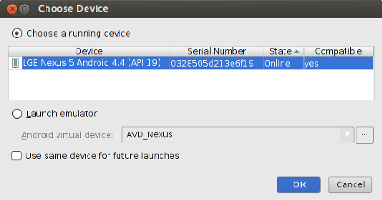
Android Studio opens the Debug tool window when you debug your app. To open the Debug window manually, click Debug
. This window shows threads and variables in the Debugger tab, the device status in the Console tab, and the system log in the Logcat tab. The Debug tool window also provides other debugging tools covered in the following sections.
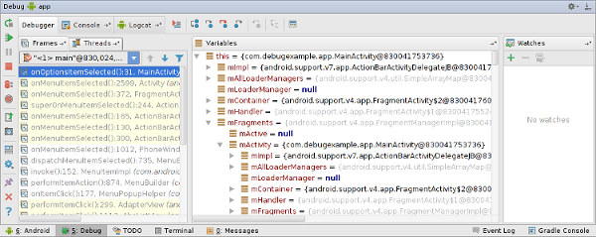
For DDMS:
DDMS is integrated into Android Studio. To use it, launch the Android Virtual Device, and click the DDMS menu button. DDMS works with both the emulator and a connected device. If both are connected and running simultaneously, DDMS defaults to the emulator.
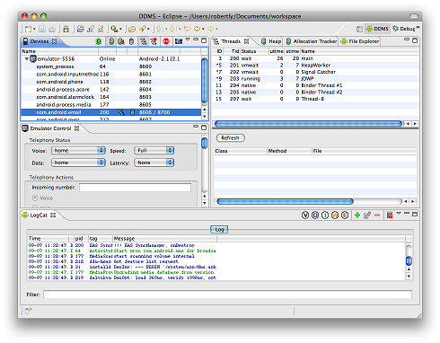

Adding Default Libraries to Module:

- Right click on module (app)>select Open Module Settings
- Project structure window will open then select one of the Module to which you what to add a library file from list of Modules displayed .
- Next select Dependencies>library file>Press + button >select Library dependency
- Next sync the gradle.

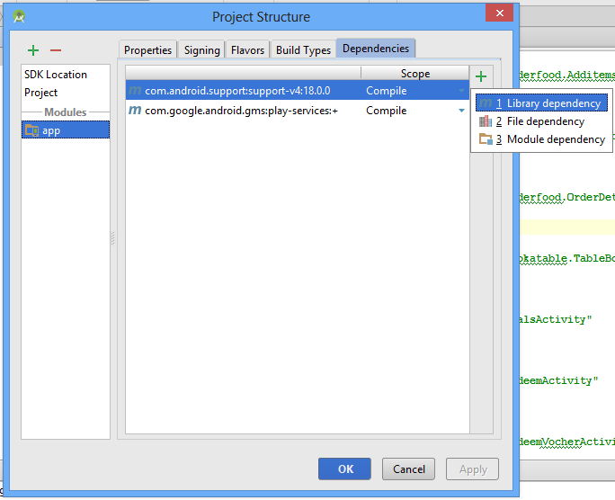

- Now the library file will be updated in build.gradle in dependencies.

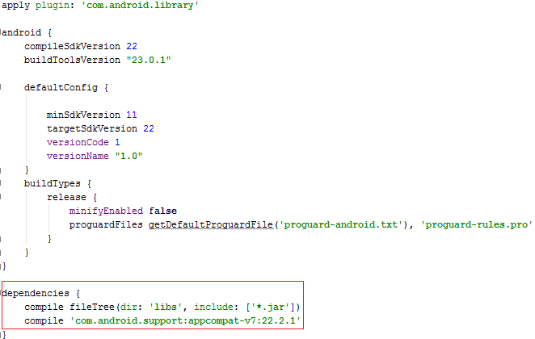

Converting Project’s Module in to custom Library:

1. Create a project.
2. open file in the left project menu.
Gradle Scripts >
build.gradle(Module: XXX)
3. change one line:
apply plugin: 'com.android.application' -> apply plugin: 'com.android.library'
4).remove applicatioId in the file
applicationId "great.example.com.testproject"

5.build project
Build > ReBuild Project
6. then you can get aar file
app > build > outputs > aar folder
7.change aar file extension name into zip
8.unzip, and you can see classes.jar in the folder.
rename it, and use it!
Adding custom library to Module(app):

1.Right click on module (app)>select Open Module Settings
2.Project structure window will open then select one of the Module to which you what to add a library file from list of Modules displayed .
3.Next select Dependencies>library file>Press + button >select Module dependency
4.Next sync the gradle.

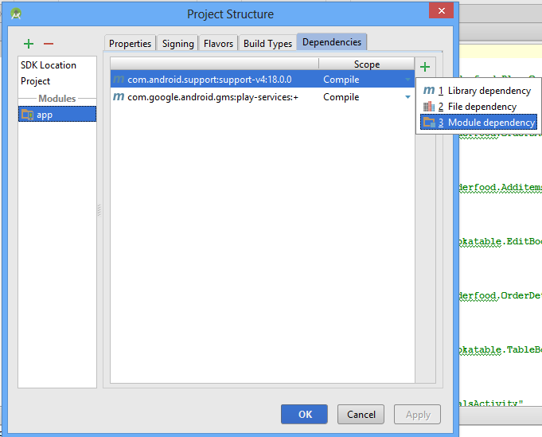

- Now the library file will be updated in build.gradle in dependencies.

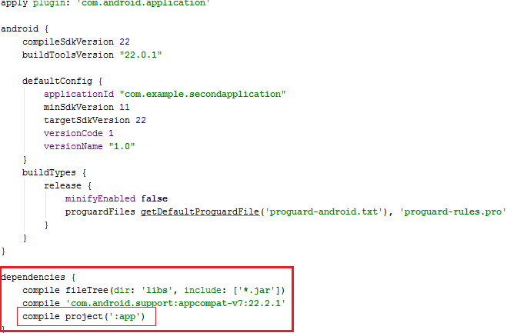

To configure eclipse shortcuts in Android studio:

- Open File menu - Settings - under the IDE settings Select keymap - Select keymaps (Ex. Eclipse, mac os ...)

